1. PRODUCT & COMPANY IDENTIFICATION
1.1 | Product Name: | CAIKLEEN™ RBR, LIQUID (LOW ODOR FORMULA), (P/N RBR100L)
1.2 | Chemical Name: | NA
1.3 | Synonyms: | CaiKleen™ RBR; P/N RBR100L
1.4 | Trade Names: | CaiKleen™ RBR PART NOs:  Part No. RBR100PS-6 (150 mL); Part No. RBR100L-P6C (6 mL); Part No. RBR100L-25C (25 mL);  Part No. RBR100L-2 (59 mL); Part No. RBR100L-12 (354 mL); Part No. RBR100L-32 (944 mL)
1.5 | Product Uses & Restrictions: | Rubber Cleaner and Rejuvenator
1.6 | Distributor’s Name: | CAIG Laboratories, Inc.
1.7 | Distributor’s Address: | 12200 Thatcher Court, Poway, CA 92064-6876 USA
1.8 | Emergency Phone: | CHEMTREC: +1 (703) 527-3887 / +1 (800) 424-9300 (CCN205206)
1.9 | Business Phone / Fax: | +1 (800) 224-4123
2. HAZARDS IDENTIFICATION
2.1 | Hazard Identification: | This product is classified as a HAZARDOUS SUBSTANCE but NOT as DANGEROUS GOODS according to the classification criteria of NOHSC: 1088 (2004) and ADG Code (Australia).  WARNING! CAUSES EYE IRRITATION. MAY CAUSE AN ALLERGIC SKIN REACTION.  Classification: Eye Irrit 2; Skin Irrit. 1B
2.2 | Label Elements: | Hazard Statements (H): H317 – May cause an allergic skin reaction. H320 – Causes eye irritation.  Precautionary Statements (P): P261 – Avoid breathing dust. P264 – Wash thoroughly after handling. P280 – Wear protective gloves. P302+P352 – IF ON SKIN: Wash with plenty of water. P333+P313 – If skin irritation or rash occurs get medical advice/attention. P305+P351+P338 – IF IN EYES: Rinse cautiously with water for several minutes. Remove contact lenses, if present and easy to do. Continue rinsing. P321 – Specific treatment see this container label. P362+P364 – Take off contaminated clothing and was it before reuse. P337+P313 – If eye irritation persists: Get medical advice/attention. P501 - Dispose of contents/container to licenses treatment, storage and disposal facility (TSDF). |  |  |  |  |  |  |  |  |  |  |  |  | 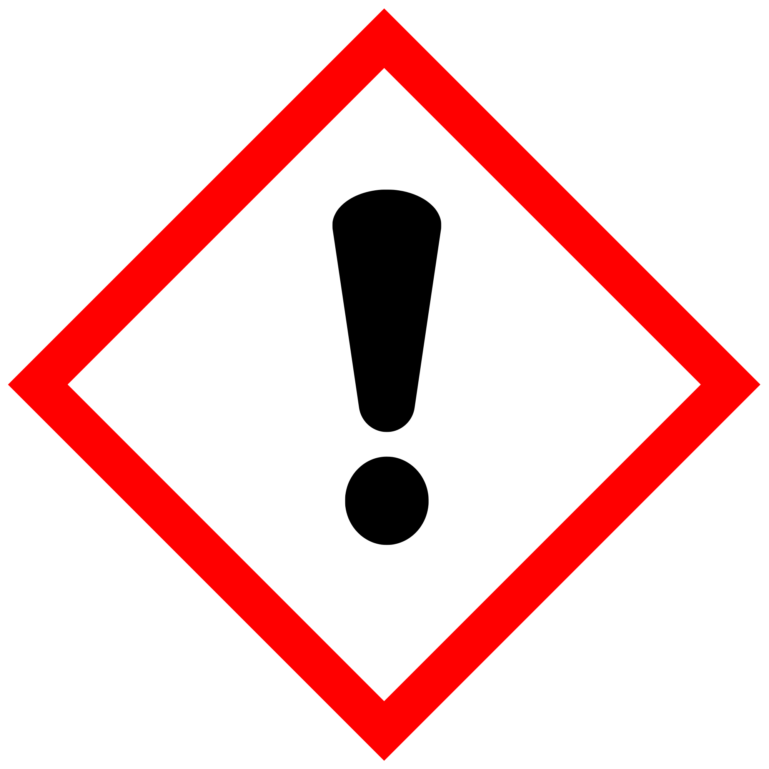
2.3 | Other Warnings: | KEEP OUT OF REACH OF CHILDREN
3. COMPOSITION & INGREDIENT INFORMATION
CHEMICAL NAME(S) |  |  | CAS No. | RTECS No. | EINECS No. | % | EXPOSURE LIMITS IN AIR (mg/m³)
 |  |  |  |  |  |  | ACGIH |  | NOHSC |  |  | OSHA |  |  |  | OTHER
 |  |  |  |  |  |  | ppm |  | ppm |  |  | ppm |  |  |  | OTHER
 |  |  |  |  |  |  | TLV | STEL | ES-TWA | ES-STEL | ES-PEAK | PEL | STEL | IDLH |  | OTHER
MINERAL OIL |  |  | 64742-30-9 | PY8030000 | 235-183-3 | 60-100 | 5 | 10 | NF | NF | NF | 5 | 3 | NA |  | MIST
CHLORINATED FATTY ESTER |  |  | 68440-29-9 | NA | 270-448-1 | 10-30 | NA | NA | NF | NF | NF | NA | NA | NA
LIMONENE |  |  | 5989-27-5 | GW6360000 | 227-813-5 | 1-5 | NA | NA | NF | NF | NF | NA | NA | NA |  | ALLERGEN
4. FIRST AID MEASURES
4.1 | First Aid: | Ingestion: If ingested, do not induce vomiting. If product has been swallowed, drink plenty of water or milk IMMEDIATELY. If the patient is vomiting, continue to offer water or milk. Never give water or milk to an unconscious person. Contact the nearest Poison Control Center or local emergency number. Provide an estimate of the time at which the material was ingested and the amount of the substance that was swallowed.  Eyes: Splashes are not likely; however, if product gets in the eyes, flush with copious amounts of lukewarm water for at least 15 minutes lifting upper and lower lids, occasionally.  Skin: Wash thoroughly with soap and water. In case of contact, immediately flush skin with plenty of water for at least 15 minutes.  Inhalation: Remove victim to fresh air at once. If breathing difficult, administer oxygen. If breathing stops give artificial respiration. Keep person warm, quiet and get medical attention.
4.2 | Effects of Exposure: | Ingestion: If product is swallowed, may cause nausea, vomiting and/or diarrhea.  Eyes: Moderately irritating to the eyes. Symptoms of overexposure may include redness, itching, irritation and watering.  Skin: May be irritating to skin. The product can cause allergic skin reactions (e.g., rashes, welts, dermatitis) in some sensitive individuals.  Inhalation: None expected.

4. FIRST AID MEASURES – cont’d
4.3 | Symptoms of Overexposure: | Ingestion: Nausea, intestinal discomfort, vomiting and/or diarrhea.  Eyes: Overexposure in eyes may cause redness, itching and watering.  Skin: Symptoms of skin overexposure may include redness, itching, and irritation of affected areas. Frostbite like symptoms. The product can cause allergic skin reactions (e.g., rashes, welts, dermatitis) in some individuals.
4.4 | Acute Health Effects: | Non-irritating when used as directed. Moderate irritation to eyes and skin near affected areas. Additionally, high concentrations of vapors can cause drowsiness, dizziness, headaches and nausea.
4.5 | Chronic Health Effects: | Non-irritating when used as directed. Overexposure may trigger asthma-like symptoms in some sensitive individuals. May also induce skin sensitization and respiratory hypersensitivity. Possible allergic dermatitis.
4.6 | Target Organs: | Eyes, Skin.
4.7 | Medical Conditions Aggravated by Exposure: | Pre-existing dermatitis, other skin conditions, and disorders of the target organs (eyes, skin, and respiratory system). |  |  |  |  |  | HEALTH |  |  |  |  |  |  |  | 1
4.7 | Medical Conditions Aggravated by Exposure: |  |  |  |  |  |  | FLAMMABILITY |  |  |  |  |  |  |  | 1
4.7 | Medical Conditions Aggravated by Exposure: |  |  |  |  |  |  | PHYSICAL HAZARDS |  |  |  |  |  |  |  | 0
4.7 | Medical Conditions Aggravated by Exposure: |  |  |  |  |  |  | PROTECTIVE EQUIPMENT |  |  |  |  |  |  |  | B
4.7 | Medical Conditions Aggravated by Exposure: |  |  |  |  |  |  | EYES |  | SKIN
5. FIREFIGHTING MEASURES
5.1 | Fire & Explosion Hazards: | This product is not flammable. However, if involved in a fire, this product may decompose at high temperatures to form toxic gases (e.g., CO,CO_{X}). |  |  |  |  |  |  |  |  |  |  |  | 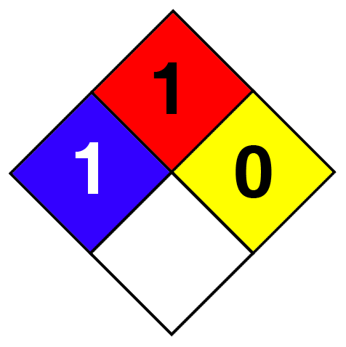
5.2 | Extinguishing Methods: | Water, Foam, CO₂, Dry Chemical, Halon (if permitted). Use water spray to cool unopened containers.
5.3 | Firefighting Procedures: | Fight fires as for surrounding materials. As in any fire, wear MSHA/NIOSH approved self-contained breathing apparatus (pressure-demand) and full protective gear. Keep containers cool until well after the fire is out. Use water spray to cool fire-exposed surfaces and to protect personal. Fight fire upwind. Avoid spraying water directly into storage containers because of danger of boil-over. Prevent runoff from fire control or dilution from entering sewers, drains, drinking water supply, or any natural waterway. Firefighters must use full bunker gear including NIOSH-approved positive pressure self-contained breathing apparatus to protect against potential hazardous combustion or decomposition products and oxygen deficiencies.
6. ACCIDENTAL RELEASE MEASURES
6.1 | Spills: | Before cleaning any spill or leak, individuals involved in spill cleanup must wear appropriate Personal Protective Equipment. Plastic or rubber gloves, respirator, eye protection and apron may be required for clean-up of large spills.  Small Spills: Wear appropriate protective equipment including gloves and protective eyewear. Use a non-combustible material such as vermiculite or sand to soak up the product and place into a container for later disposal. Do not use water or a material such as “speedy dry” to soak up material. Sweep up material using non-sparking materials (e.g., plastic brooms, shovels, dustpans) and place into a plastic container or plastic liner within another container.  Large Spills: Keep incompatible materials (e.g., organics such as oil) away from spill. Stay upwind and away from spill or release. Isolate immediate hazard area and keep unauthorized personnel out of area. Stop spill or release if it can be done with minimal risk. Wear appropriate protective equipment including respiratory protection as conditions warrant.
7. HANDLING & STORAGE INFORMATION
7.1 | Work & Hygiene Practices: | Do not eat, drink or smoke when handling this product. Contents under pressure. Handle as to avoid puncturing container(s). When used as intended, no additional protective equipment is necessary. Use chemical goggles if eye contact is possible. Wash unintentional residues with soap and warm water.
7.2 | Storage & Handling: | Use and store in a cool, dry, well-ventilated location (e.g., local exhaust ventilation, fans) away from heat and direct sunlight. Avoid temperatures above 120 °F. Keep away from incompatible substances. Protect containers from physical damage. To avoid unintentional spraying keep cap in place when not in use.
7.3 | Special Precautions: | Clean all spills promptly. Spilled material may present a slipping hazard.
8. EXPOSURE CONTROLS & PERSONAL PROTECTION
8.1 | Exposure Limits:  ppm (mg/m³) | CHEMICAL NAME(S) | ACGIH |  | NOHSC |  |  |  | OSHA |  |  |  | OTHER
8.1 | Exposure Limits:  ppm (mg/m³) | CHEMICAL NAME(S) | TLV | STEL | ES-TWA | ES-STEL | ES-PEAK |  | PEL | STEL | IDLH
8.1 | Exposure Limits:  ppm (mg/m³) | MINERAL OIL | 5 | 10 | NF | NF | NF |  | 5 | 3 | NA |  | MIST
8.1 | Exposure Limits:  ppm (mg/m³) | LIMONENE | NA | NA | NF | NF | NF |  | NA | NA | NA |  | ALLERGEN
8.2 | Ventilation & Engineering Controls: | General mechanical (e.g., fans) or natural ventilation is sufficient when this product is in use. Use local or general exhaust ventilation to effectively remove and prevent buildup of vapors or mist generated from the handling of this product. Ensure appropriate decontamination equipment is available (e.g., sink, safety shower, eye-wash station).
8.3 | Respiratory Protection: | No special respiratory protection is required under typical circumstances of use or handling. In instances where dusts of this product are generated, and respiratory protection is needed, use only protection authorized by 29 CFR §1910.134, applicable U.S. State regulations, or the Canadian CAS Standard Z94.4-93 and applicable standards of Canadian Provinces, EC member States, or Australia.

8. EXPOSURE CONTROLS & PERSONAL PROTECTION – cont’d
8.4 | Eye Protection: | Avoid eye contact. Wear splash proof goggles or equivalent eye protection (ANSI Z87). Safety glasses need to be used when handling or using this product. |  |  |  |  |  | 
8.5 | Hand Protection: | Impermeable gloves required. May cause skin irritation in some sensitive individuals. When handling wear rubber, nitrile or impervious plastic gloves. |  |  |  |  |  | 
8.6 | Body Protection: | No apron required when handling small quantities. When handling large quantities (e.g., ≥ 5 lbs), eye wash stations and deluge showers should be available. Upon completion of work activities involving large quantities of this product, wash any exposed areas thoroughly with soap and water.
9. PHYSICAL & CHEMICAL PROPERTIES
9.1 | Appearance: |  | Amber liquid
9.2 | Odor: |  | Citrus odor
9.3 | Odor Threshold: |  | NA
9.4 | pH: |  | NA
9.5 | Melting Point/Freezing Point: |  | NA
9.6 | Initial Boiling Point/Boiling Range: |  | NA
9.7 | Flashpoint: |  | >93.3 ºC (200 ºF)
9.8 | Upper/Lower Flammability Limits: |  | NA
9.9 | Vapor Pressure: |  | 0.01 mm Hg @ 20 ºC
9.10 | Vapor Density: |  | NA
9.11 | Relative Density: |  | 0.913
9.12 | Solubility: |  | Negligible
9.13 | Partition Coefficient (log P_{ow}): |  | NA
9.14 | Autoignition Temperature: |  | NA
9.15 | Decomposition Temperature: |  | NA
9.16 | Viscosity: |  | NA
9.17 | Other Information: |  | NVC 60-70%
10. STABILITY & REACTIVITY
10.1 | Stability: |  | Stable under normal conditions; unstable with heat or contamination.
10.2 | Hazardous Decomposition Products: |  | Oxides of carbon (CO, CO₂).
10.3 | Hazardous Polymerization: |  | Will not occur.
10.4 | Conditions to Avoid: |  | Open flames, sparks, high heat, incompatible substances and direct sunlight.
10.5 | Incompatible Substances: |  | Avoid extreme heat and ignition sources. Store away from oxidizers.
11. TOXICOLOGICAL INFORMATION
11.1 | Routes of Entry: |  | Inhalation: | YES | Absorption: | YES | Ingestion: |  | YES
11.2 | Toxicity Data: |  | This product has NOT been tested on animals to obtain toxicology data. Toxicology data, found in scientific literature, is available for some of the components of the product:  Mineral Oil: LD50 (oral, rat) > 5,000 mg/kg
11.3 | Acute Toxicity: |  | Moderate irritation to eyes and skin near affected areas.
11.4 | Chronic Toxicity: |  | This material may aggravate any pre-existing skin condition (e.g., dermatitis).
11.5 | Suspected Carcinogen: |  | IARC 3 (not classifiable as to carcinogenicity in humans (for mineral oils, highly refined))
11.6 | Reproductive Toxicity: |  | This product is not reported to produce reproductive toxicity in humans.
 | Mutagenicity: |  | This product is not reported to produce mutagenic effects in humans.
 | Embryotoxicity: |  | This product is not reported to produce embryotoxic effects in humans.
 | Teratogenicity: |  | This product is not reported to cause teratogenic effects in humans.
 | Reproductive Toxicity: |  | This product is not reported to cause reproductive effects in humans.
11.7 | Irritancy of Product: |  | The product can cause allergic skin reactions (e.g., rashes, welts, dermatitis) upon prolonged or repeated exposure.
11.8 | Biological Exposure Indices: |  | NE
11.9 | Physician Recommendations: |  | Treat symptomatically.
12. ECOLOGICAL INFORMATION
12.1 | Environmental Stability: |  | There is no specific data available for this product.
12.2 | Effects on Plants & Animals: |  | There are no specific data available for this product.
12.3 | Effects on Aquatic Life: |  | There are no specific data available for this product; however, very large releases of this product may be harmful or fatal to overexposed aquatic life.

13. DISPOSAL CONSIDERATIONS
13.1 | Waste Disposal: | Products covered by this SDS, in their original form, when disposed as waste, are considered non hazardous waste according to Federal RCRA regulations (40 CFR 261). Disposal should be in accordance with local, state and federal regulations. Dispose of in accordance with federal, state and local regulations.
13.2 | Special Considerations: | The user of this material has the responsibility to dispose of unused material, residues and containers in compliance with all relevant local, state, federal and provincial regulations.
14. TRANSPORTATION INFORMATION
The basic description (ID Number, proper shipping name, hazard class & division, packing group) is shown for each mode of transportation. Additional descriptive information may be required by 49 CFR, IATA/ICAO, IMDG and the CTDGR.
14.1 | 49 CFR (GND): | NOT REGULATED
14.2 | IATA (AIR): | NOT REGULATED
14.3 | IMDG (OCN): | NOT REGULATED
14.4 | TDGR (Canadian GND): | NOT REGULATED
14.5 | ADR/RID (EU): | NOT REGULATED
14.6 | SCT (MEXICO): | NOT REGULATED
14.7 | ADGR (AUS): | NOT REGULATED
15. REGULATORY INFORMATION
15.1 | SARA Reporting Requirements: | This product does not contain any substances subject to SARA Title III, section 313 reporting requirements.
15.2 | SARA Threshold Planning Quantity: | There are no specific Threshold Planning Quantities for the components of this product.
15.3 | TSCA Inventory Status: | The components of this product are listed on the TSCA Inventory.
15.4 | CERCLA Reportable Quantity (RQ): | NA
15.5 | Other Federal Requirements: | NA
15.6 | Other Canadian Regulations: | This product has been classified according to the hazard criteria of the Controlled Products Regulations (CPR) and the SDS contains all of the information required by the CPR. The components of this product are listed on the DSL/NDSL. None of the components of this product are listed on the Priorities Substances List. |  |  | 
15.7 | State Regulatory Information: | Mineral Oil is found on the following state criteria lists: NJ, PA.  No other ingredients in this product, present in a concentration of 1.0% or greater, are listed on any of the following state criteria lists: California Proposition 65 (CA65), Delaware Air Quality Management List (DE), Florida Toxic Substances List (FL), Massachusetts Hazardous Substances List (MA), Michigan Critical Substances List (MI), Minnesota Hazardous Substances List (MN), New Jersey Right-to-Know List (NJ), New York Hazardous Substances List (NY), Pennsylvania Right-to-Know List (PA), Washington Permissible Exposures List (WA), Wisconsin Hazardous Substances List (WI).
15.8 | Other Requirements: |  | This product does not contain any chemicals known to the State of California to cause cancer or other reproductive harm. For more information go to www.P65Warnings.ca.gov.
16. OTHER INFORMATION
16.1 | Other Information: | WARNING! CAUSES EYE IRRITATION. MAY CAUSE AN ALLERGIC SKIN REACTION. Use only as directed. Keep out of reach of children. Avoid contact with skin. Avoid contact with eyes. Wear suitable protective clothing. In case of accident or if you feel unwell seek medical advice immediately (show the label where possible). If skin irritation occurs: get medical advice/attention. KEEP LOCKED UP AND OUT OF REACH OF CHILDREN.
16.2 | Terms & Definitions: | See last page of this Safety Data Sheet.
16.3 | Disclaimer: | This Safety Data Sheet is offered pursuant to OSHA’s Hazard Communication Standard, 29 CFR §1910.1200. Other government regulations must be reviewed for applicability to this product. To the best of ShipMate's & CAIG Laboratories, Inc.’s knowledge, the information contained herein is reliable and accurate as of this date; however, accuracy, suitability or completeness is not guaranteed and no warranties of any type, either expressed or implied, are provided. The information contained herein relates only to the specific product(s). If this product(s) is combined with other materials, all component properties must be considered. Data may be changed from time to time. Be sure to consult the latest edition.
16.4 | Prepared for: | CAIG Laboratories, Inc.  12200 Thatcher Court  Poway, CA 92064-6876  Tel: +1 (800) CAIG-123 (244-4123)  Fax: +1 (858) 486-8398 fax  http://www.caig.com/ |  | 
16.5 | Prepared by: | ShipMate, Inc.  P.O. Box 787  Sisters, Oregon 97759-0787 USA  Tel: +1 (310) 370-3600  Fax: +1 (310) 370-5700  http://www.shipmate.com |  | 

DEFINITION OF TERMS

A large number of abbreviations and acronyms appear on a SDS. Some of these that are commonly used include the following:

GENERAL INFORMATION:

CAS No. | Chemical Abstract Service Number
RTECS No. | Registry of Toxic Effects of Chemical Substances Number
EINECS No. | European Inventory of Existing Commercial Chemical Substances Number

EXPOSURE LIMITS IN AIR:

ACGIH | American Conference on Governmental Industrial Hygienists
IDLH | Immediately Dangerous to Life and Health
NOHSC | National Occupational Health and Safety Commission (Australia)
OSHA | U.S. Occupational Safety and Health Administration
PEL | Permissible Exposure Limit
STEL | Short Term Exposure Limit
TLV | Threshold Limit Value
TWA | Time Weighted Average

FIRST AID MEASURES:

CPR | Cardiopulmonary resuscitation - method in which a person whose heart has stopped receives manual chest compressions and breathing to circulate blood and provide oxygen to the body.

HAZARDOUS MATERIALS IDENTIFICATION SYSTEM: HMIS

HEALTH, FLAMMABILITY & REACTIVITY RATINGS:

0 | Minimal Hazard |  | HEALTH
1 | Slight Hazard |  | FLAMMABILITY
2 | Moderate Hazard |  | PHYSICAL HAZARDS
3 | Severe Hazard |  | PERSONAL PROTECTION
4 | Extreme Hazard

PERSONAL PROTECTION RATINGS:

A |  |  |  |  |  | G |  |  | 
B |  |  |  |  |  | H |  |  | 
C |  |  |  |  |  | I
D |  |  |  |  |  | J |  |  | 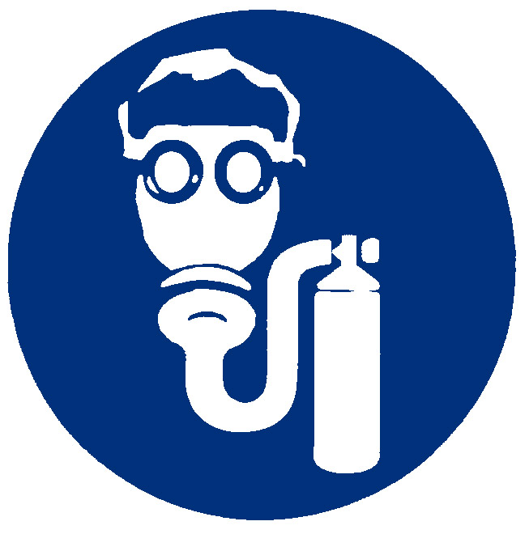
E |  |  |  |  |  | K | 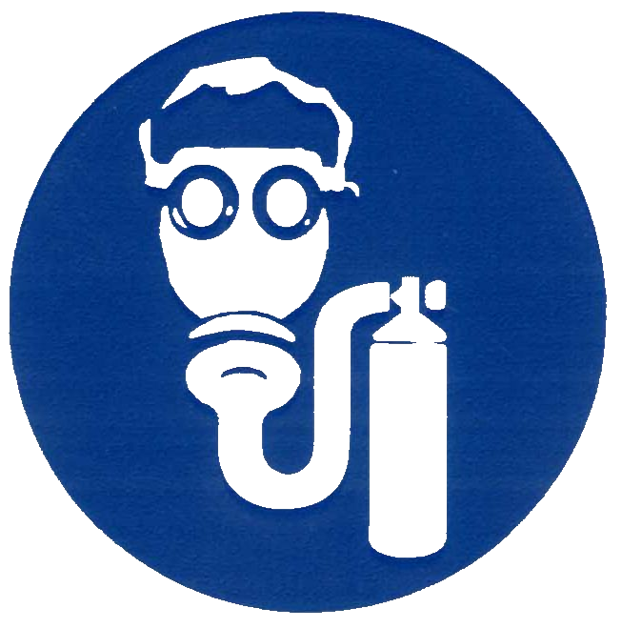 |  |  | 
F |  |  |  |  |  | X | Consult your supervisor or SOPs for special handling directions.

Safety Glasses | Splash Goggles | Face Shield & Protective Eyewear | Gloves
Boots | Protective Apron |   Protective Clothing & Full Suit | Dust Respirator
  Full Face Respirator | Dust & Vapor Half-Mask Respirator | Full Face Respirator | Airline Hood/Mask or SCBA

OTHER STANDARD ABBREVIATIONS:

Carc | Carcinogenic
Irrit | Irritant
NA | Not Available
NR | No Results
ND | Not Determined
NE | Not Established
NF | Not Found
SCBA | Self-Contained Breathing Apparatus
Sens | Sensitization
STOT RE | Specific Target Organ Toxicity – Repeat Exposure
STOT SE | Specific Target Organ Toxicity – Single Exposure

NATIONAL FIRE PROTECTION ASSOCIATION: NFPA

FLAMMABILITY LIMITS IN AIR:
Autoignition Temperature | Minimum temperature required to initiate combustion in air with no other source of ignition
LEL | Lower Explosive Limit - lowest percent of vapor in air, by volume, that will explode or ignite in the presence of an ignition source
UEL | Upper Explosive Limit - highest percent of vapor in air, by volume, that will explode or ignite in the presence of an ignition source

HAZARD RATINGS:

0 | Minimal Hazard | 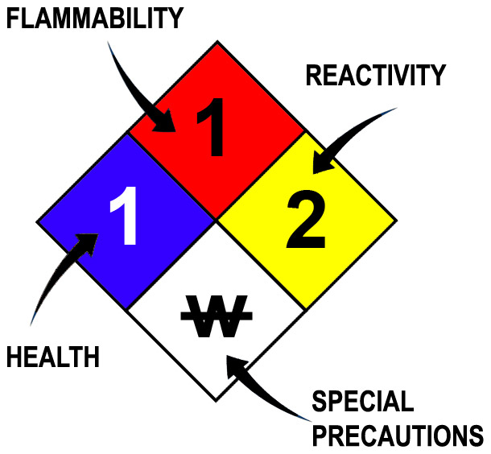
1 | Slight Hazard
2 | Moderate Hazard
3 | Severe Hazard
4 | Extreme Hazard
ACD | Acidic
ALK | Alkaline
COR | Corrosive
W | Use No Water
OX | Oxidizer
TREFOIL | Radioactive

TOXICOLOGICAL INFORMATION:

LD₅₀ | Lethal Dose (solids & liquids) which kills 50% of the exposed animals
LC₅₀ | Lethal concentration (gases) which kills 50% of the exposed animal
ppm | Concentration expressed in parts of material per million parts
TD_{lo} | Lowest dose to cause a symptom
TCLo | Lowest concentration to cause a symptom
TD_{lo}, LD_{lo}, & LD_{o} or  TC, TC_{o}, LC_{lo}, & LC_{o} | Lowest dose (or concentration) to cause lethal or toxic effects
IARC | International Agency for Research on Cancer
NTP | National Toxicology Program
RTECS | Registry of Toxic Effects of Chemical Substances
BCF | Bioconcentration Factor
TL_{m} | Median threshold limit
log K_{OW} or log K_{OC} | Coefficient of Oil/Water Distribution

REGULATORY INFORMATION:

WHMIS | Canadian Workplace Hazardous Material Information System
DOT | U.S. Department of Transportation
TC | Transport Canada
EPA | U.S. Environmental Protection Agency
DSL | Canadian Domestic Substance List
NDSL | Canadian Non-Domestic Substance List
PSL | Canadian Priority Substances List
TSCA | U.S. Toxic Substance Control Act
EU | European Union (European Union Directive 67/548/EEC)
WGK | Wassergefährdungsklassen (German Water Hazard Class)

WORKPLACE HAZARDOUS MATERIALS IDENTIFICATION (WHMIS) SYSTEM:

 |  |  |  |  |  | 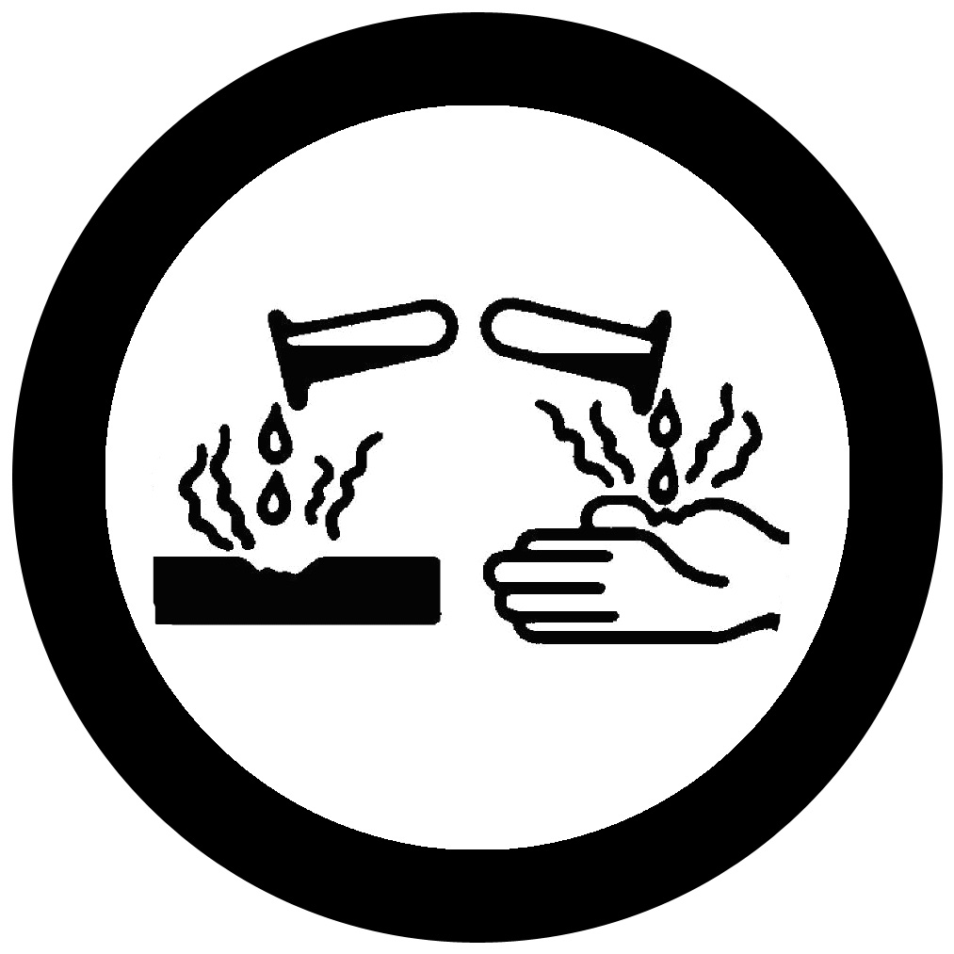 | 
Class A | Class B | Class C | Class D1 | Class D2 | Class D3 | Class E | Class F
Compressed | Flammable | Oxidizing | Toxic | Irritation | Infectious | Corrosive | Reactive

CLP/GHS (1272/2008/EC) PICTOGRAMS:

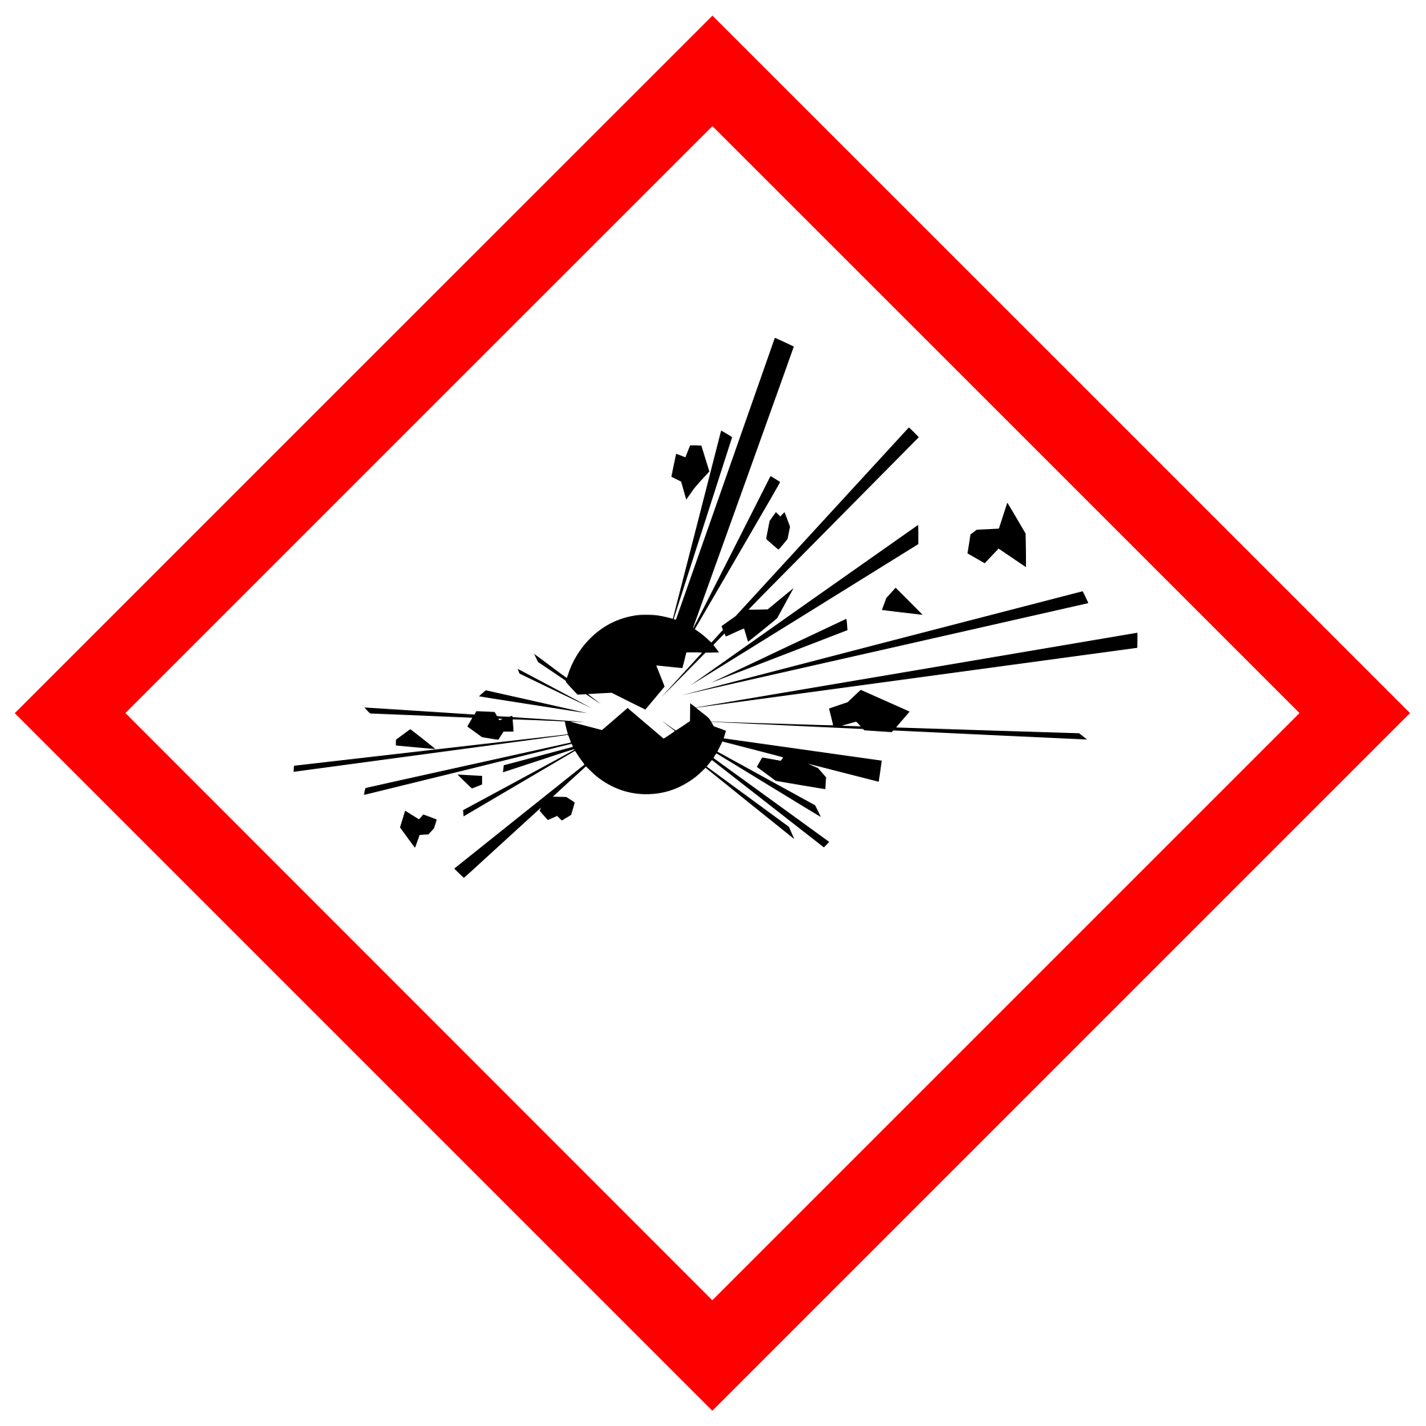 | 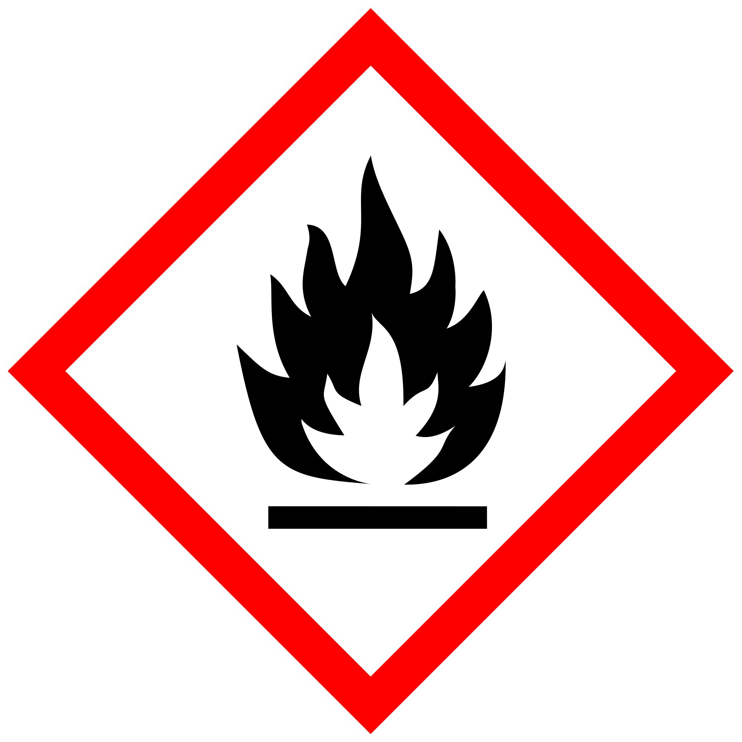 | 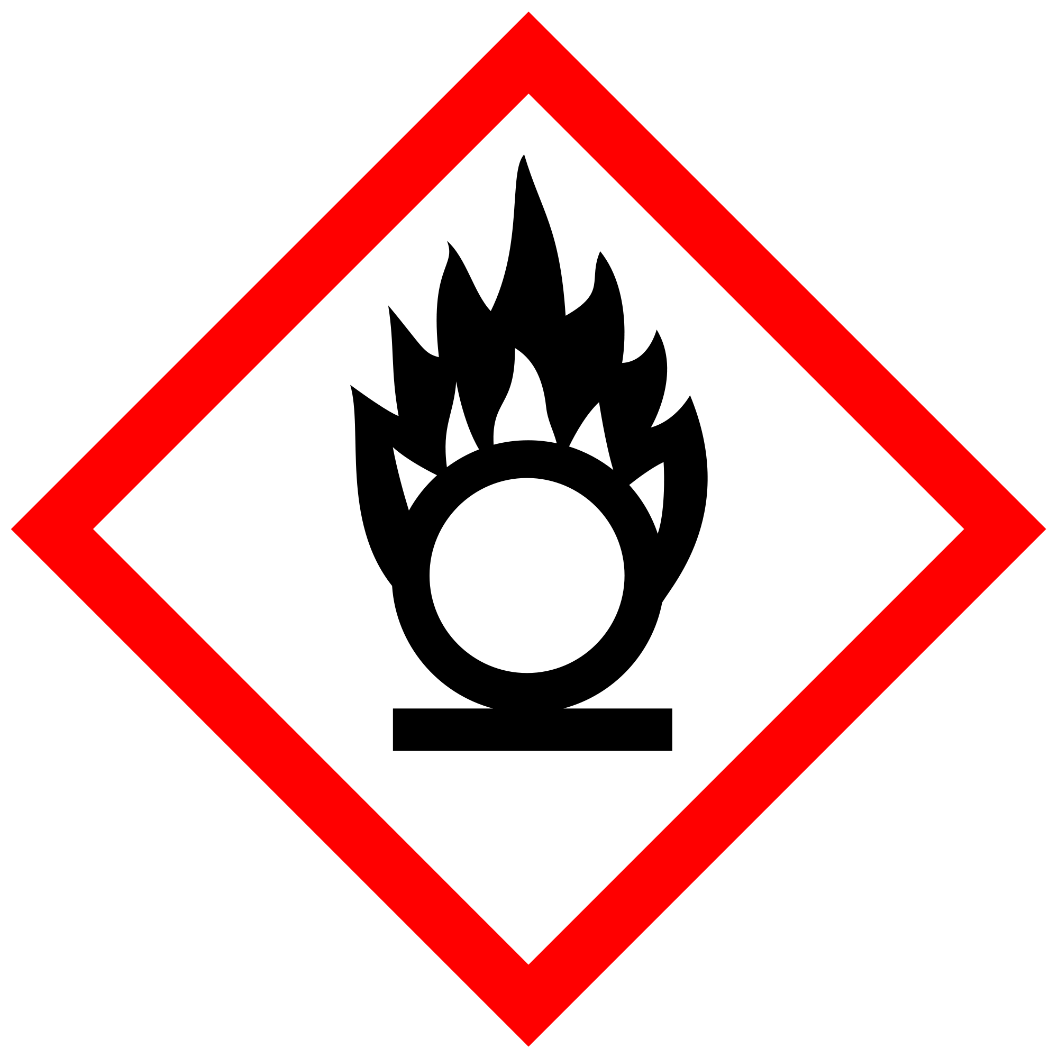 | 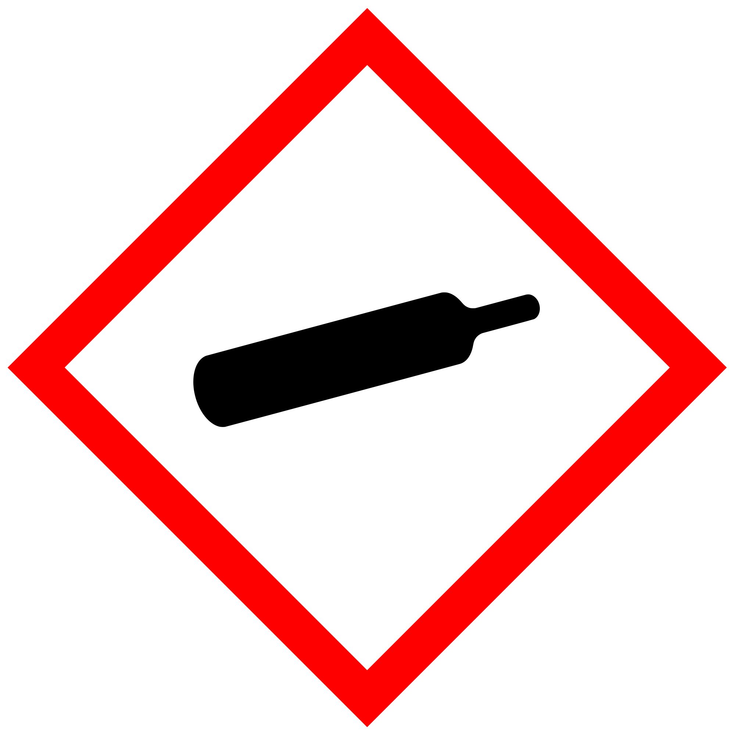 | 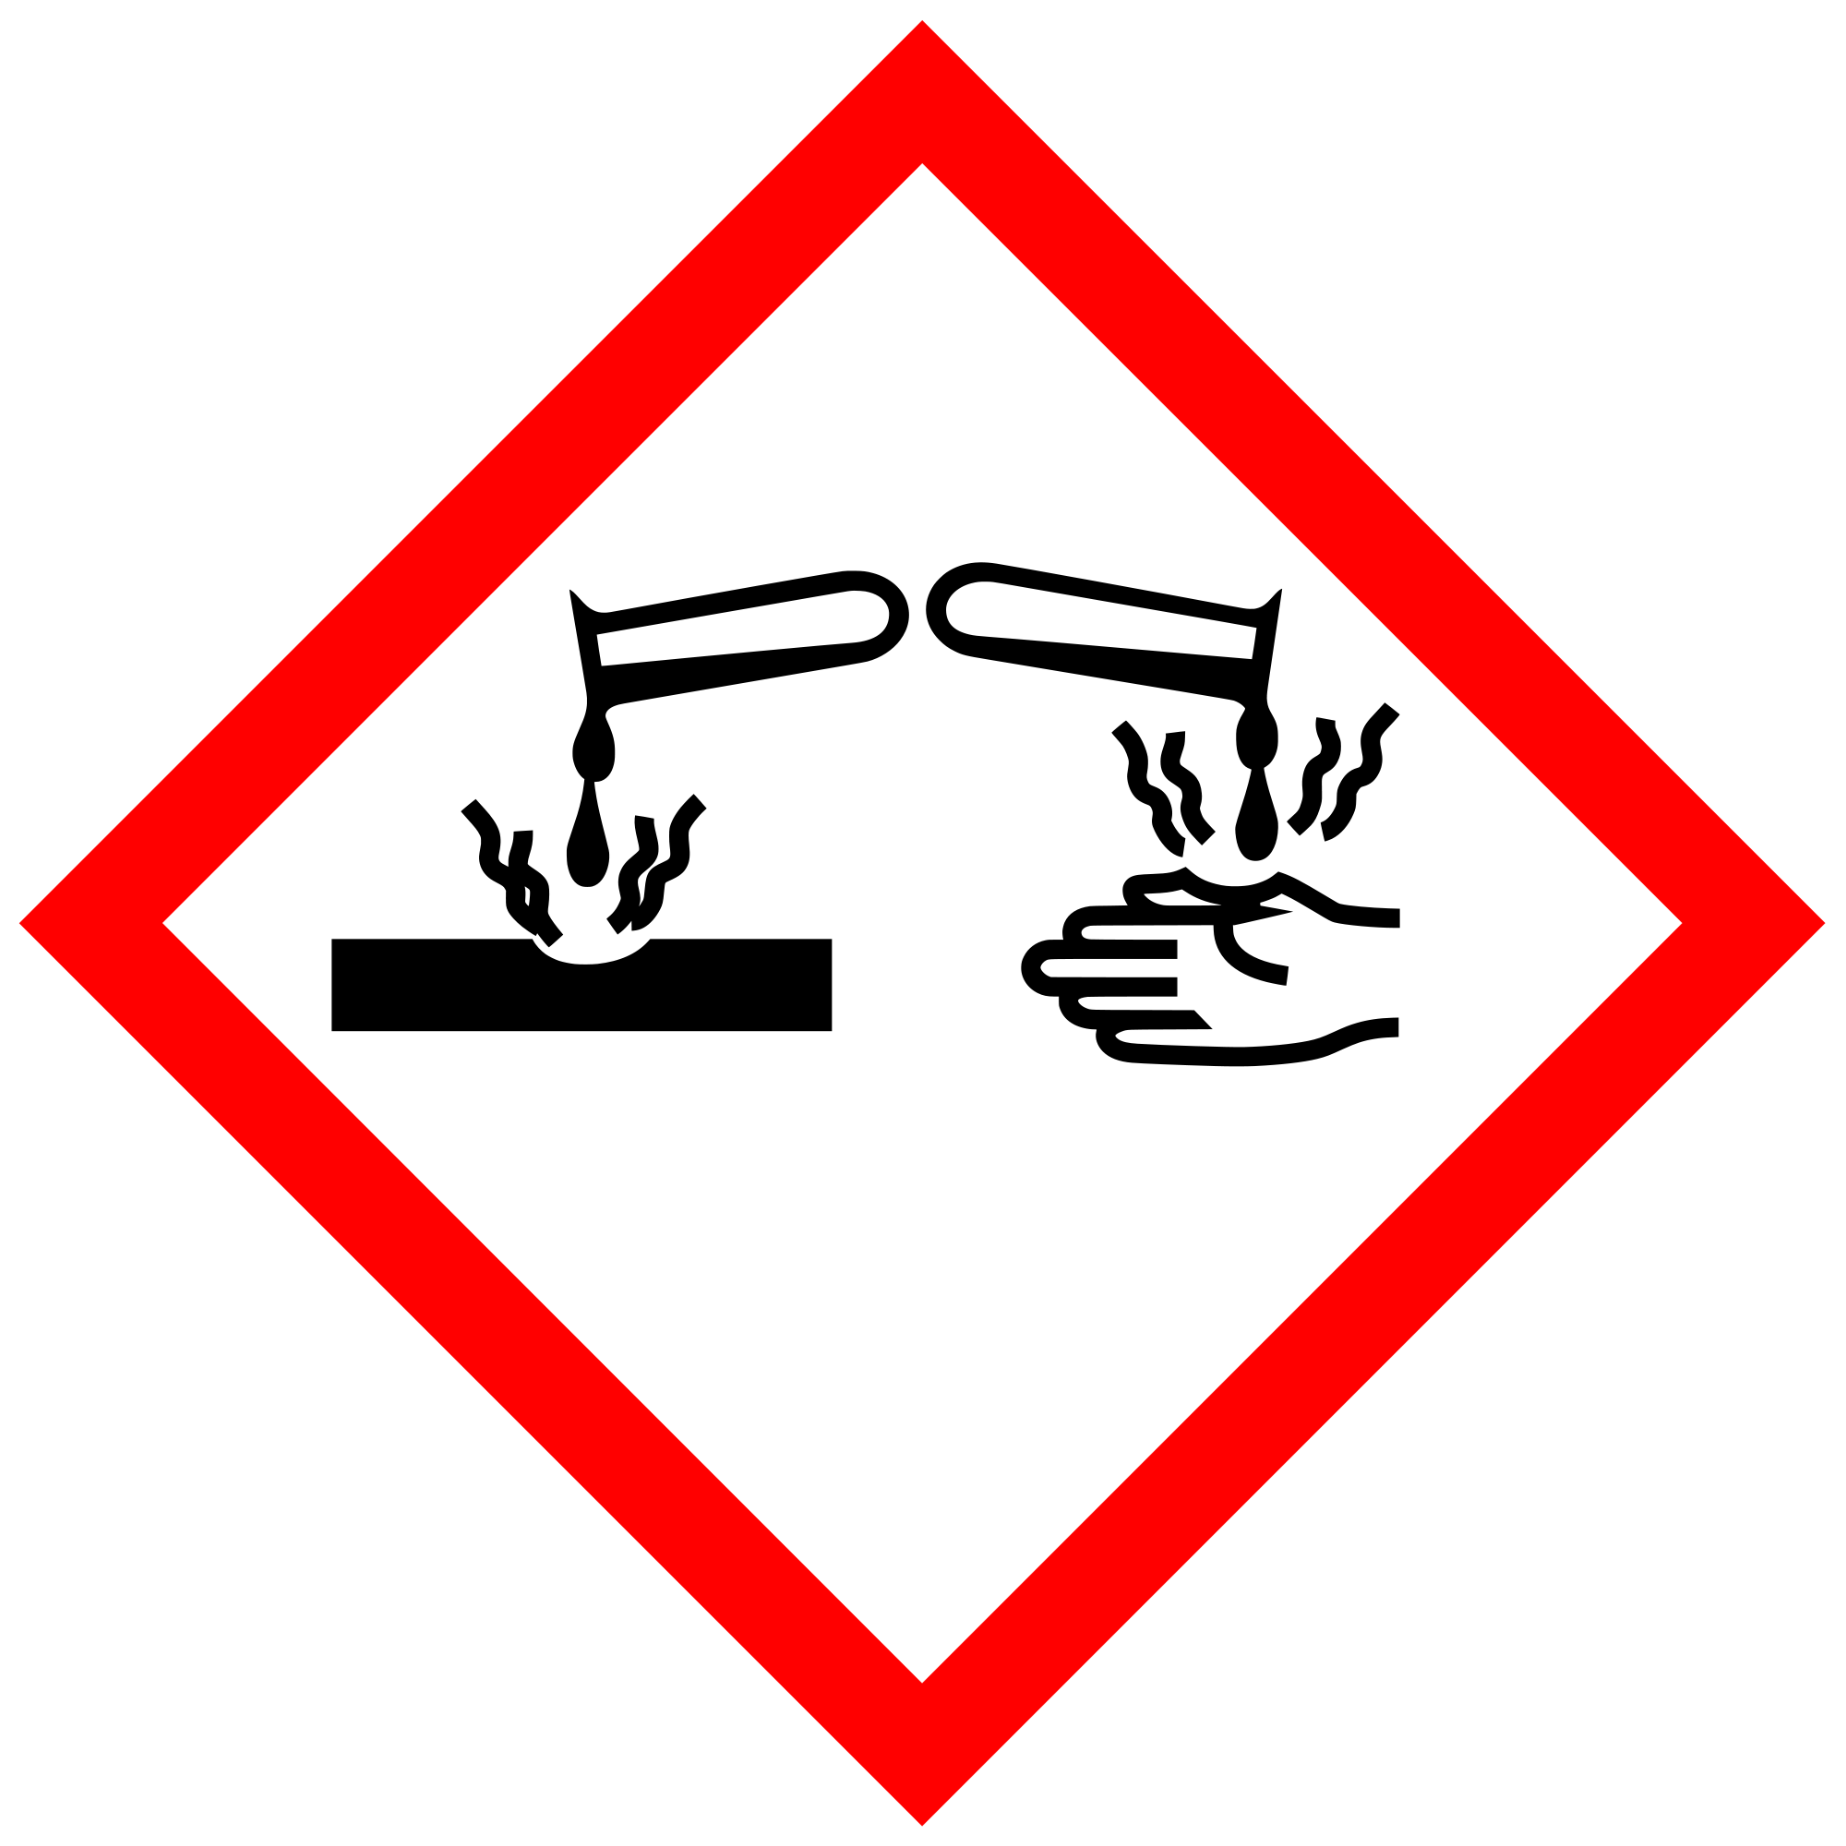 | 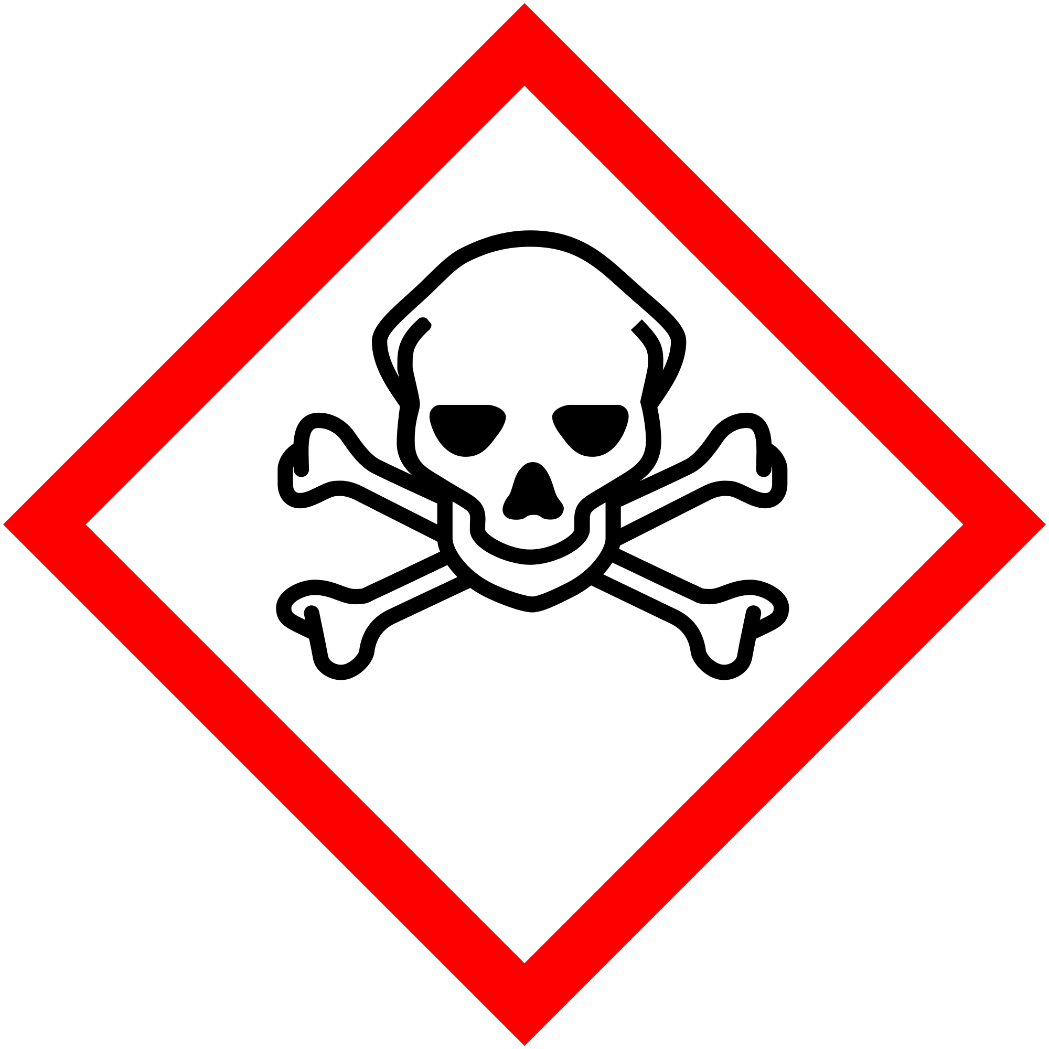 |  | 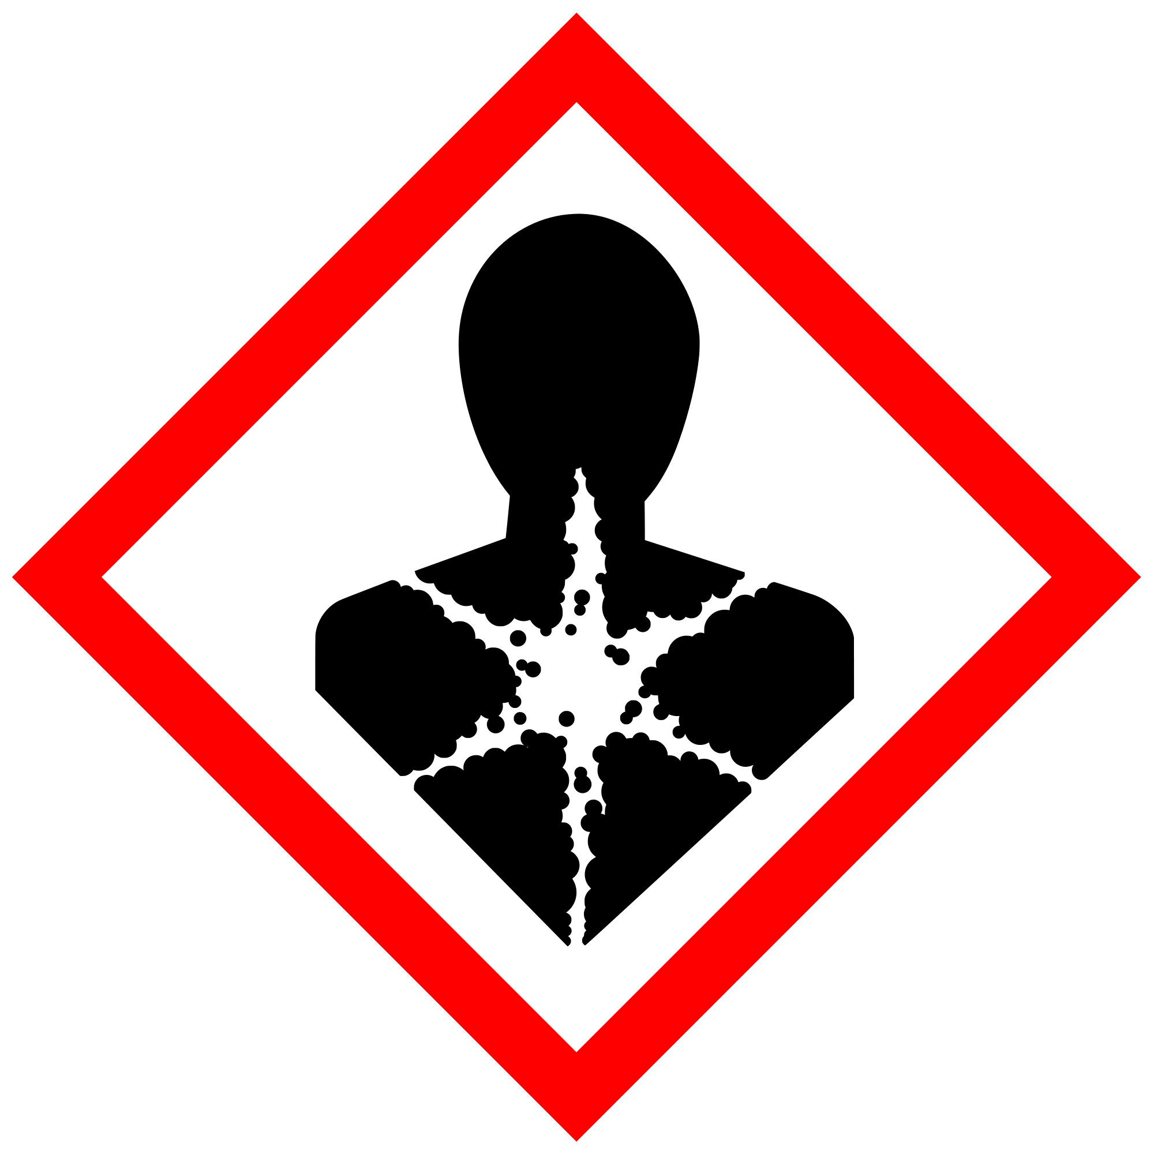 | 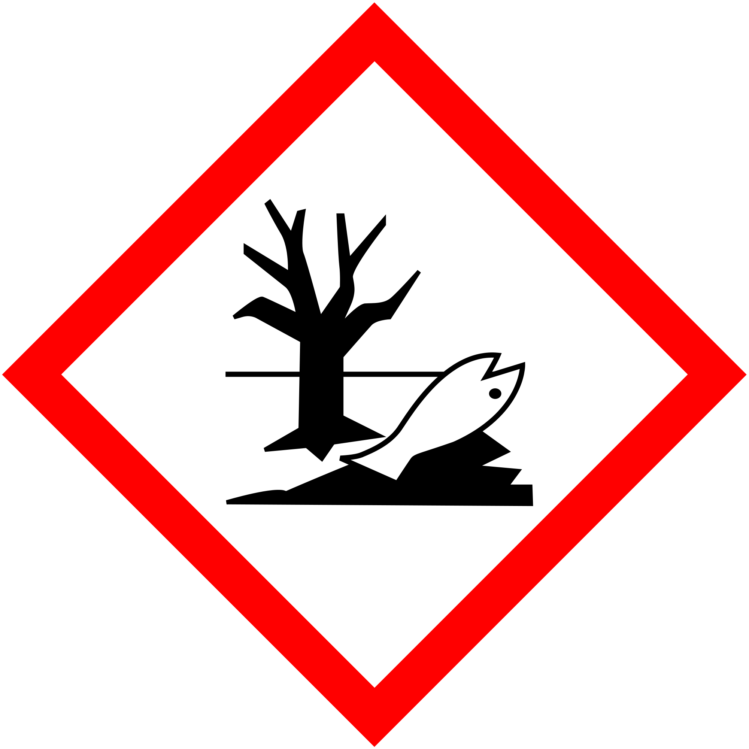
GHS01 | GHS02 | GHS03 | GHS04 | GHS05 | GHS06 | GHS07 | GHS08 | GHS09
Explosive | Flammable | Oxidizer | Pressurized | Corrosive | Toxic | Harmful  Irritating | Health  Hazard | Environment

